Filling out PDF Forms
**Note** The below instructions only work if you have an Adobe program such as Adobe Acrobat DC or Adobe Reader downloaded to your computer. If you do not have an Adobe Program, you must print the document to complete. **

- Open the applicable document
- All documents require signatures in order to be processed. To complete the form by including your authentic signature, click on “Fill and Sign” from the vertical menu found on the right side of the document. (shown as the eighth tool in the diagram below). If you do not want to sign digitally, you only need to open the document.
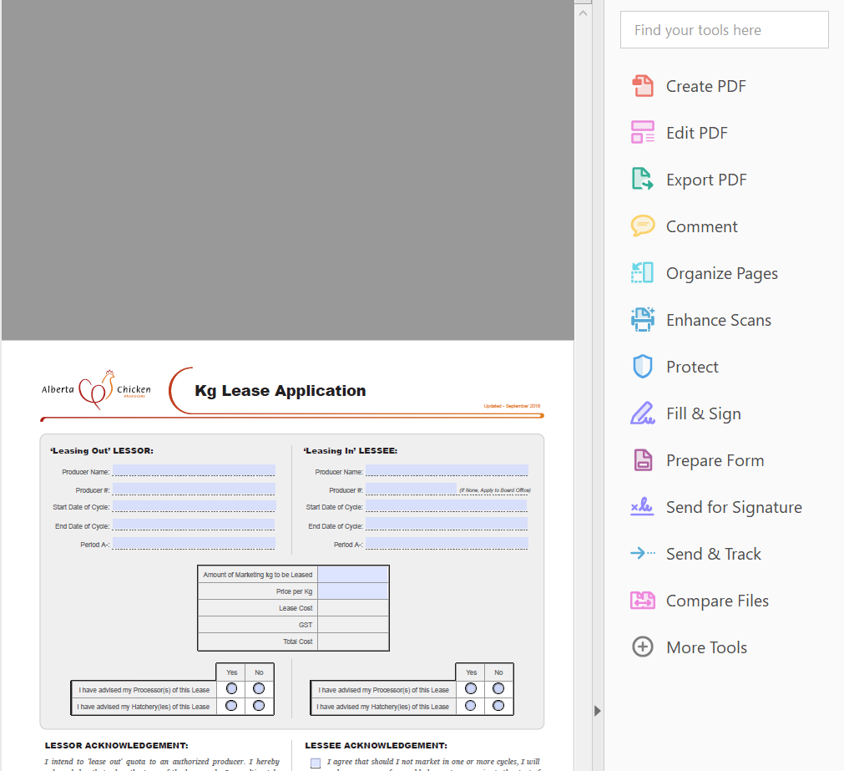
- Click your cursor on the line or box you need to fill out first and fill in the box. Use the tab keys to navigate between the boxes. The “tab” key will automatically take you to each empty box. If you do not need to fill out the box, click tab again to go to the next box. It is imperative that you fill in as many of the boxes that you can. Failure to fill in boxes may result in a delay in the processing of your request.
- When you arrive at a “Date” box, a dropdown arrow key will appear at the end of the box. Click on the down arrow key and a calendar will appear with today’s date highlighted. Click on the date you need. The arrow keys beside the month and year will adjust the calendar forward or back a month.
- To check mark your selection in the ☐ check box, click on the box and an check mark will appear. You are allowed to make more than one selection where check boxes are shown, so make sure you check the right box. If you check a box in error, you must recheck that box to remove the check mark.
- A ◌ button will only allow one selection
- If you do not wish to add a digital signature to the document, complete the document and print for distribution. It is a good idea to save the document you have completed so you have a back-up or to reference at a later date. To Save the document, click on “File” in the top left hand corner, then “Save As”. Name your file and save it to your desktop or in your designated folder. You must sign the form prior to forwarding the document to the ACP office, or others who need to fill out the form. Alternatively, you may use the “Send for Signature” option and you can email your completed and signed form to the next party.
- Instruction to add a digital signature: (Be aware that your signature will be sent via a nonencrypted site).
  - Click on the Pencil and Sign icon at the top of the page. Beside “Add signature” click on the +(plus) button.
  - Type, Draw and Image will appear on the top.
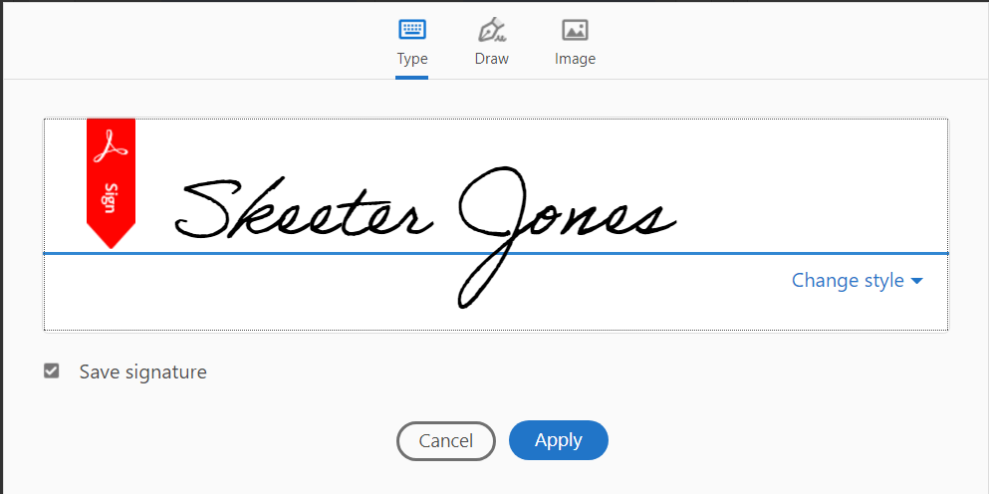
  - If you have never used this option before, you will probably notice “type” is highlighted and a signature that although maybe our name, is not yours (note: the name of the person logged into the computer will appear). Reminder that if you chose to use this signature, you agree to all terms of the document.
  - Click on the “Draw” tool, to sign the document using your mouse.
  - 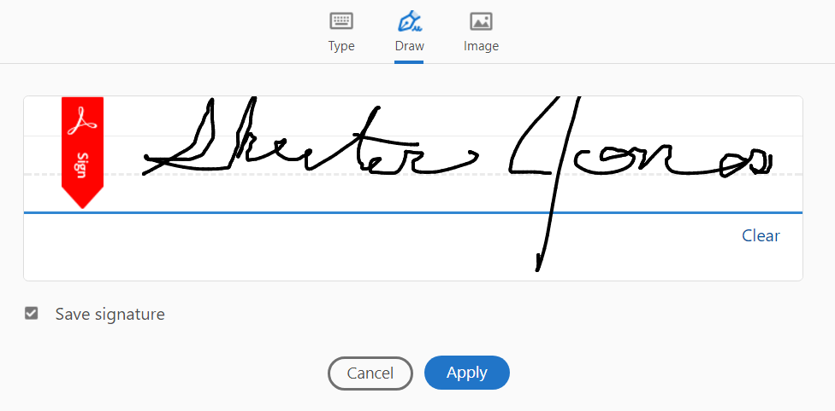
  - If you have your signature saved in an image format, you would click on this “Image” icon and insert your signature. HINT: Make sure your signature in the image is dark enough to read.
  - 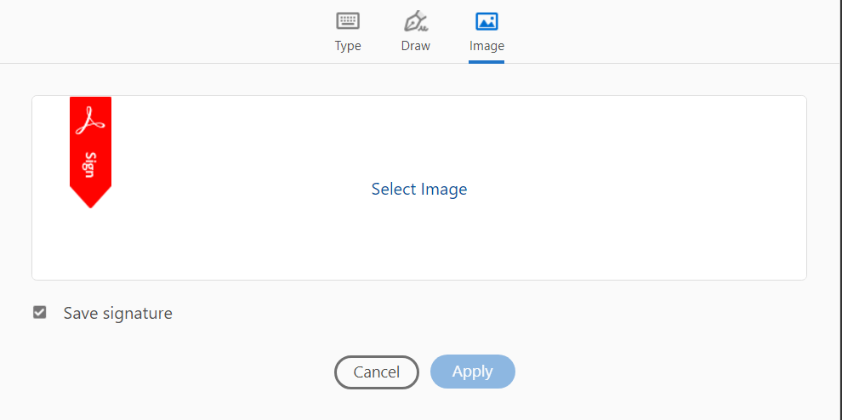
  - If you check the “Save Signature” box, your signature will be saved for future use.
  - Click the “Apply” button.
  - Drag and drop your signature to the line you need to sign.
- Save your file. Since your document is already signed, you may be able to click on the “File” button again and send via email using the “Send File” to item and then “Attach to an email” option. Alternatively, you can start fresh with a new email and send the document is an attachment.
- If you are satisfied that your document is completely filled out and does not require the signature of your hatchery, processor, another producer etc. The email address to forward the document to the Alberta Chicken Producers office is located in the bottom right hand corner of the document.
- Should you encounter problems, please call Twila at 780-488-2125 and she will assist you.

